Study 24
How to calculate a Rocket
Or
… "and on Mars will blossom apple trees"
In this Study are considered issues of the carrier rocket motion: one- and two-stage. It is told about Tsiolkovsky's formula and about the choice of a place for a cosmodrome. Differential equations with a condition in formulas are solved numerically and analytically in this Study. The topic of using mathematical formulas for the construction of monuments is discussed.
Mathematics: solution of algebraic and differential equations. We also discuss in Study the manual calculations made by the characters of a feature film.
Physics: rocket motion, Tsiolkovsky formula, Einstein's theory of relativity, acceleration of gravity, Earth rotation.
IT: solution of an equation, the operator of choice.
Art: Soviet films and songs, Monument to the conquerors of space in Moscow
Study website: https://community.ptc.com/t5/PTC-Mathcad-Questions/Two-stage-rocket/m-p/89686
There is such a Soviet cult movie "Nine Days of One Year". There are no chases and fights in which modern young and not very young spectators "sat down", but there are beautiful dialogues performed by beautiful actors: Tatyana Lavrova, Innokenty Smoktunovsky, Alexei Batalov, and others.
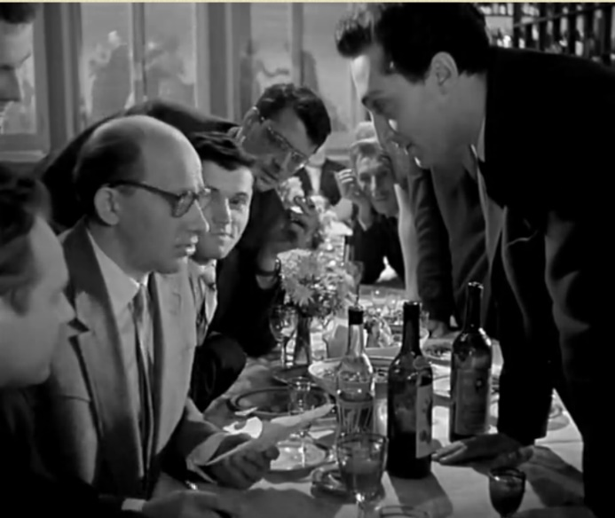
Fig. 24.1. Shot from the movie "Nine Days of One Year"
Here is one such dialogue from the film (Figure 24.1): actors Yevgeniy Yevstigneyev (theoretical physicist Nikolai Ivanovich — left) and Mikhail Kazakov (romantic physicist Valery Ivanovich — right):
—"Tell me, Valery Ivanovich, how deepl are you going to penetrate the depths of our galaxy?"
—At first only to the depth of 500 light years.
— At what speed?
— Close to the speed of light.
—The weight of your ship?
— One hundred thousand tonnes.
— The Fuel?
— The most upgraded.
—. Now we will calculate how much fuel you will need. Be kind, napkin.
…
—Nikolai Ivanovich, have you finished your calculations?
—Yes please. For a space ship of one hundred thousand tonnes weight at a speed close to the speed of light, in order to fly around a part of the galaxy in a reasonable time for human life, you need ten in twenty-two degrees 9710 of the most modern extra-fuel. As reference: Our planet weighs a little less, happy journey!
The dialogue is, of course, naive, but imagine that Nikolai Ivanovich does not have a napkin in his hands, but ... a "tablet" (tablet computer) with the Mathcad program, and he makes calculations on it (Figure 24.2).
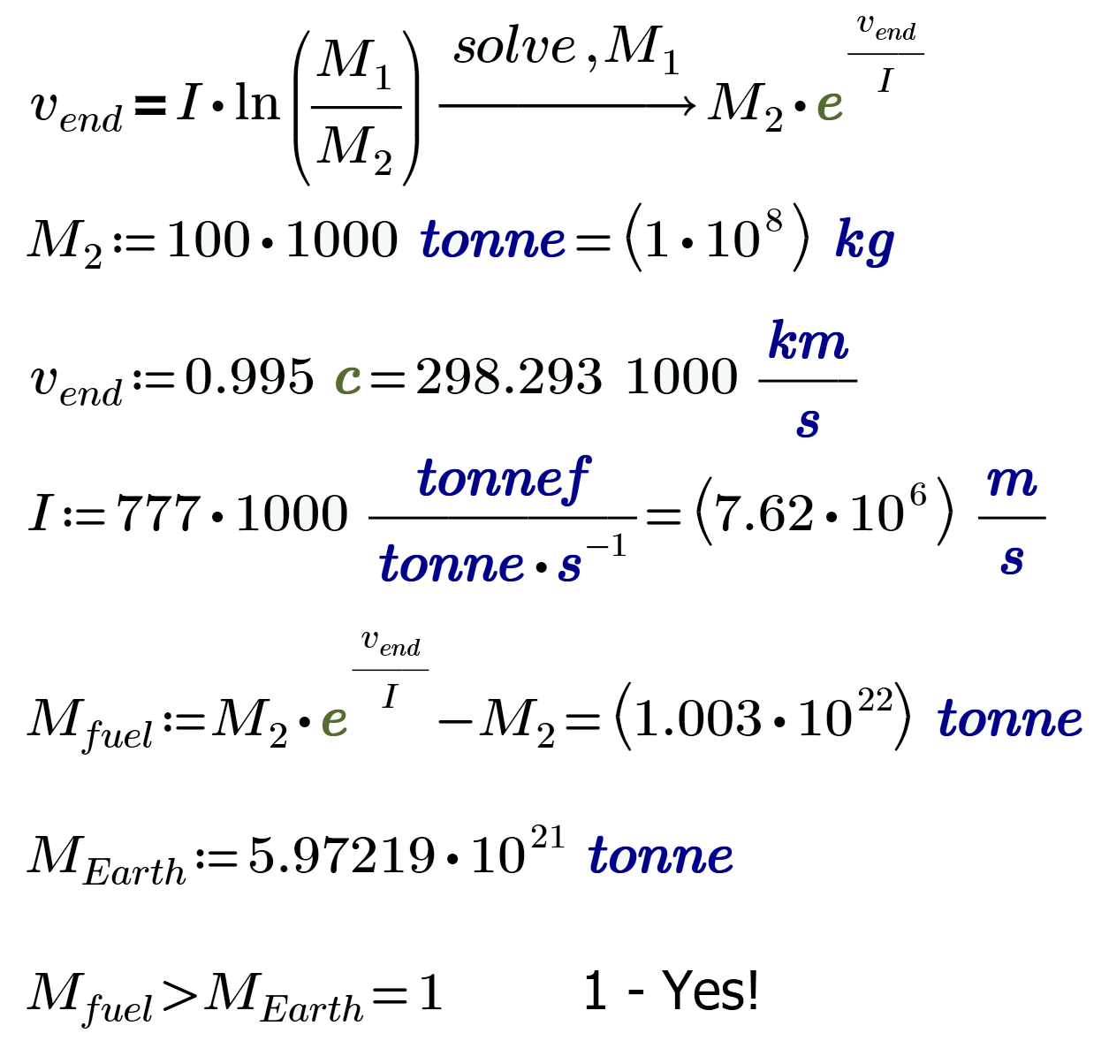
Fig. 24.2. The assumption of the calculation on the napkin
In the calculation in Figure 24.2, Tsiolkovsky's formula was used (by the way, Tsiolkovsky himself is mentioned in the movie): the final velocity of the rocket v_{end} is proportional to the natural logarithm of the ratio of the starting mass of the rocket М₁ to its final mass М₂. The difference М₁ – М₂ — is the mass of fuel and oxidant (hereinafter — simply fuel, as in the film). The proportionality factor in this equation (the value of I) is the ratio of the thrust of the engine F to the fuel mass consumption μ (the quantities F and μ will be used in further calculations).
We took I equal to 777 thousand tonnes of force/(tonne/s). But in the film this figure is not announced, 777 thousand is our assumption (three sevens for happiness!). The value of I is also the velocity of the outflow of gases from the rocket nozzle (meters per second). The theoretical value of this velocity for nuclear rocket engines can exceed 70 km/s. The exhaust velocity for an electric motor can reach 140 km/s. Therefore, it is quite possible to dream about the "three sevens".
The Tsiolkovsky equation in Figure 24.2 is solved with respect to the variable М₁. If the final speed of the rocket is close to the speed of light (we assumed that this speed is 0.995 of the speed of light c), then the mass of fuel actually exceeds the mass of the Earth (M_{Earth}). But our calculation is, of course, very rude ("naive"). In addition, he does not take into account the important fact that at speeds close to the speed of light, Tsiolkovsky's formula does not work. Here it will be necessary to depart from the laws of classical mechanics and resort to the theory of relativity of Einstein.
But let's go down from the galactic heights to near-earth space, a little (a hundred times) slow down the rocket and calculate what parameters can be in real, rather than in semi-fantastic spacecraft. We have already done a similar calculation in the study 9 — see Fig. 9.14 and Fig. 9.37.
Figure 24.3 makes an attempt to calculate the speed of a rocket having a starting mass of 250 tonnes, of which 10 tonnes is the payload (P), 40 tonnes is the mass of an empty carrier rocket (m), and 200 tonnes is the mass of fuel (M). The thrust of the rocket engine (F) is 2000 tonnes of force with a fuel consumption of 5 tonnes per second (tonnes/s — μ). With such initial data, the engine will operate for 40 seconds (t_{end}).
Figure 24.3 shows the numerical solution of the differential equation: the engine pushes the rocket up, and its weight pulls the rocket downward. And all this is balanced by the product of the mass of the rocket to its acceleration — the first derivative of its velocity in time.
The numerical solution of the differential equation of rocket motion — the function v(t) generated by points, is compared on the graph with the analytical solution (with the function v_{sym}(t)) found with the Maple (see Figure 24.4). By this action, we actually derived the Tsiolkovsky formula, used in the solution in Figure 24.2, additionally inserting in it the allowance for the acceleration of gravity (the weight of the rocket). But the constant g is not a constant, but a variable, and we already wrote about this earlier (see in the study 1 of Figure 1.27) and we'll talk further about this.
Note. The graph in Figure 24.3 shows not one, but two curves: a thick solid pale and a thin dashed black inside a thick curve. Thus, the coincidence of the numerical and analytical (symbolic) solutions of the differential equation is verified.
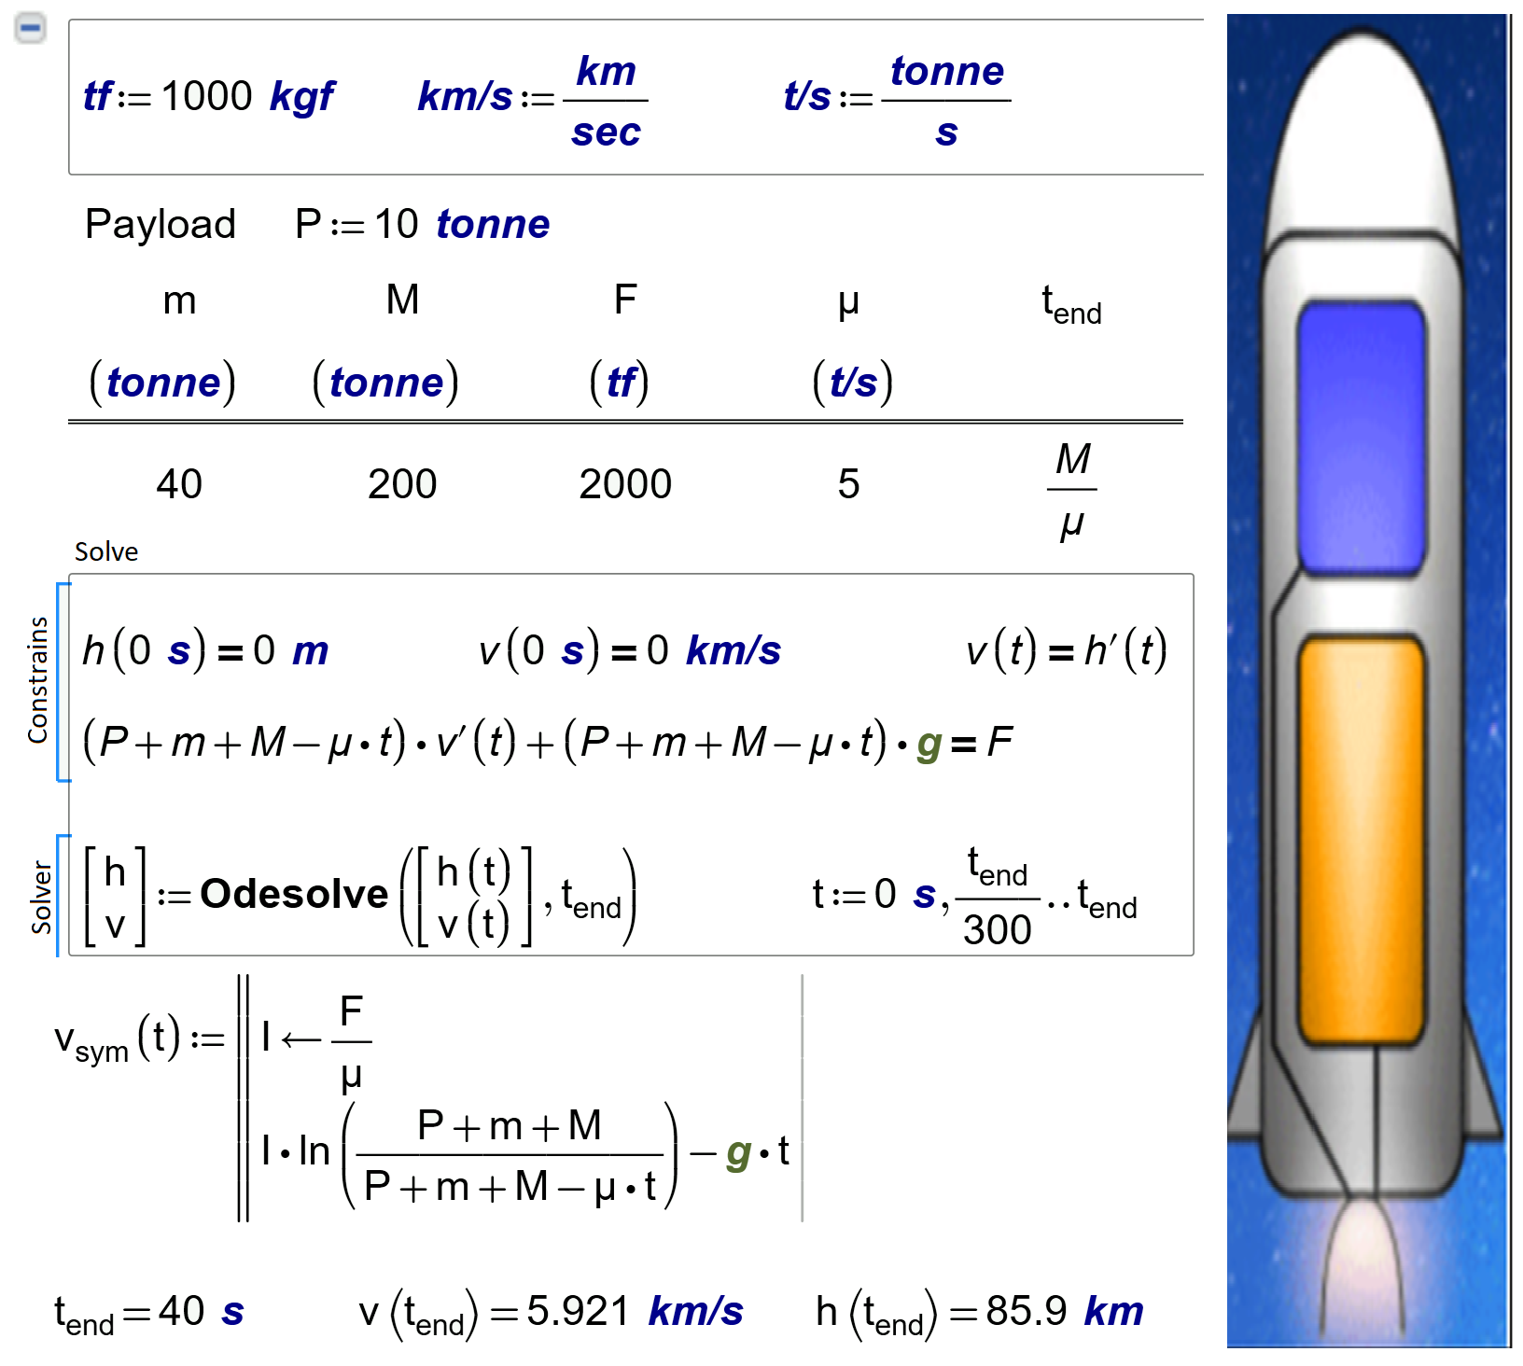
a)
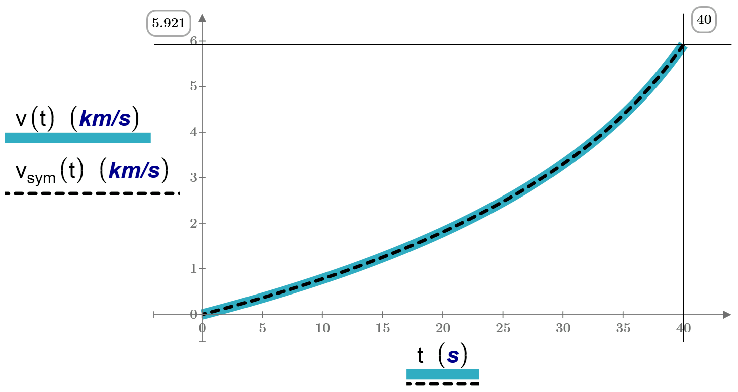
b)
Fig. 24.3. A single-stage rocket: a) a calculation, b) a plot
If in the equation the weight of the rocket (P + m + M – µ · t) · g is transferred to the right side with a minus sign, then Newton's second law is obtained in pure form. Mathematically, of course, this will not change anything, but it will be more visible.
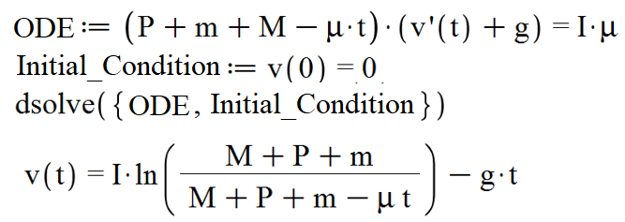
Fig. 24.4. The derivation of the Tsiolkovsky equation
Calculation in Figure 24.3 shows that the speed of the rocket at the end of the engine (5.921 km / s) does not reach the first cosmic speed (≈7.9 km/s): the rocket after its turn by 90° (this is done by additional engines or gyroscopes) will not fly on a near-Earth, but on a ballistic orbit and will soon fall to the ground.
To carry our 10 tonnes of payload to the near-earth orbit, it is still possible to increase the fuel supply. However it is better to divide the rocket into two stages (Figure 24.5).
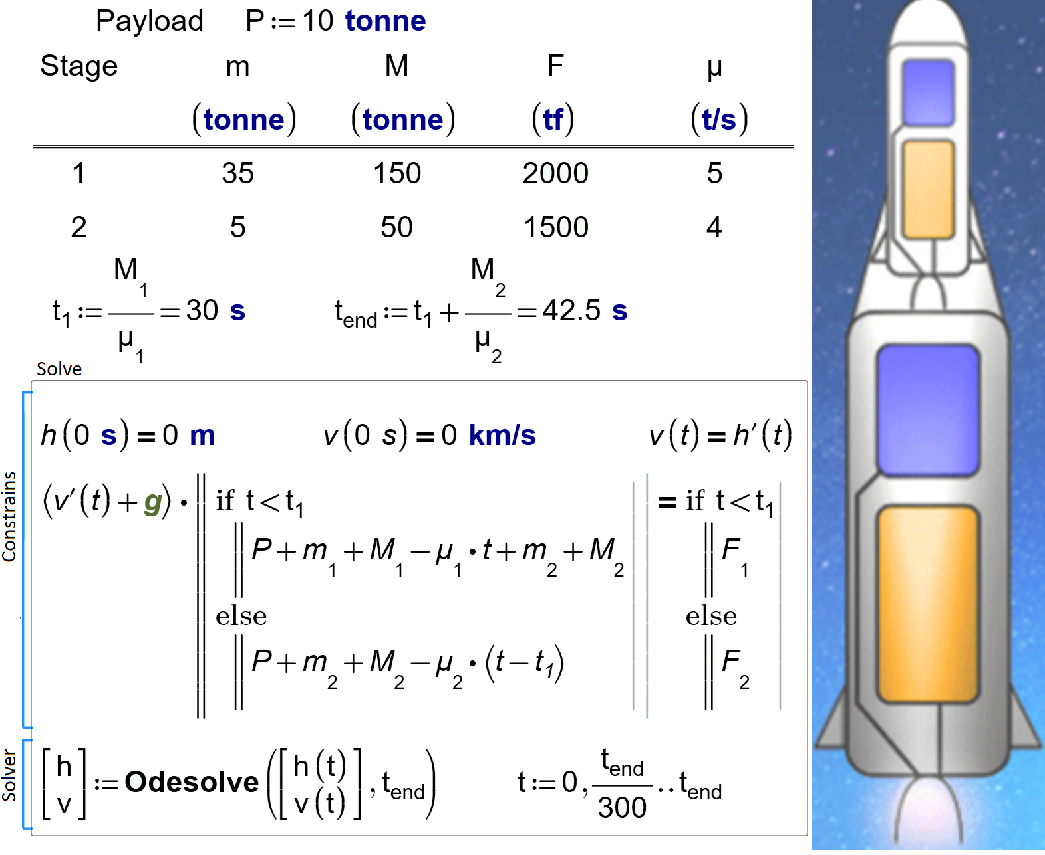
a)
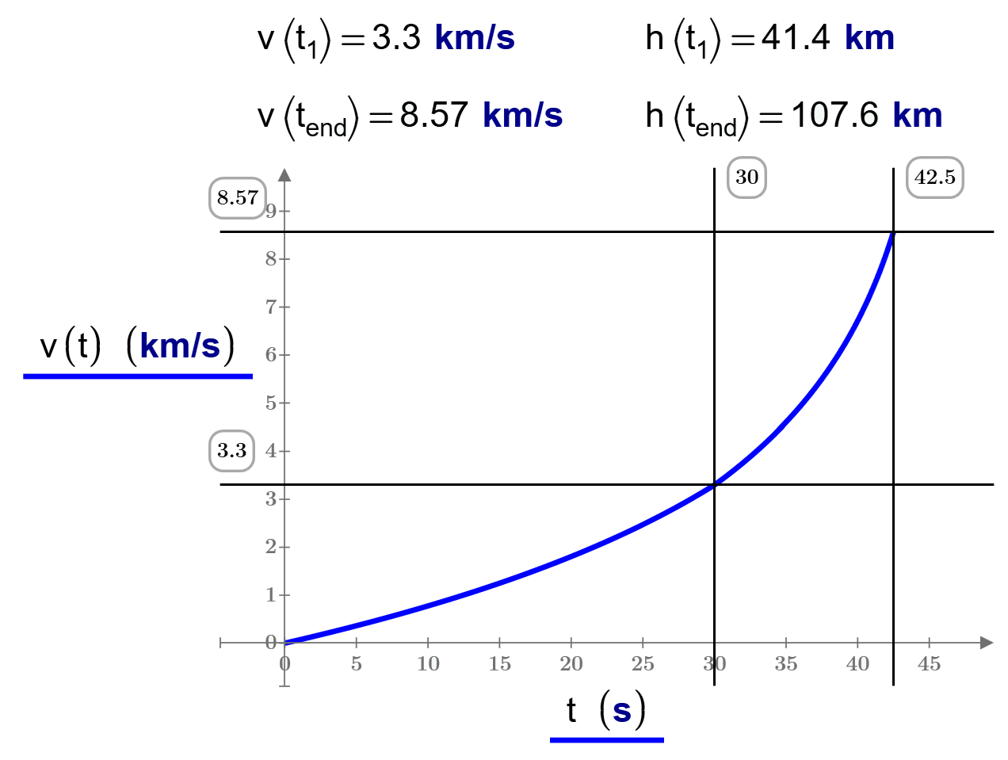
b)
Fig. 24.5. Calculation of the flight of a two-stage rocket: a) a calculation, b) a plot
The differential equation of the flight of a two-stage rocket will contain the built-in operators of Mathcad if: if the first stage with thrust F₁ is operating, it carries the payload Р, the two stages (m₁ and m₂ ), the fuel of the second stage М₂ and the consumable fuel of the first stage М₁ – μ₁ ∙ t. The second step (the else operator) with thrust F₂ will carry only the payload P, the m₂ itself and the consumable fuel M₂ – μ₂ ∙ (t – t₁), where t₁ is the time of the first stage operation, and t is the total flight time of the rocket. In this scenario, the speed of the rocket at the end of the sequential operation of two stages (8.57 km / s) will exceed the first space velocity and the satellite will be put into orbit. At the same time, the rocket (or rather, its second stage) rises by 107.6 km, and not by 85.9 km (single-stage version).
The curves shown in Figures 24.3 and 24.5 are similar to... the upper generatrix and edges of the monument to the conquerors of the cosmos established in Moscow (Figure 24.6 – see http://www.kosmo-museum.ru/?locale=en).
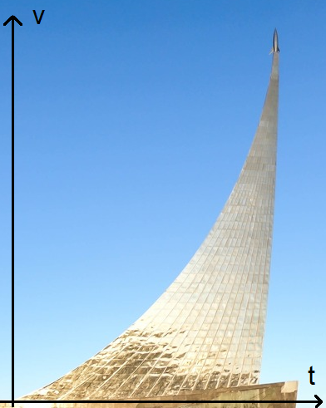
Fig. 24.6. Monument to the conquerors of space in Moscow (author’s photo)
I wonder if Tsiolkovsky's formula is embedded in this monument or is it an accidental coincidence? But Tsiolkovsky himself is present at the foot of the monument in the form of a statue.
In the calculations in Figures 24.3-24.5, of course, many assumptions have been made : It does not take into account the effect of the air flow on the rocket, the change in the magnitude of the free fall acceleration, depending on the height and geographical latitude. By the way, about latitude. It is known that the launching of rockets from the Earth should be carried out as close as possible to the equator and deploy the orbital station in an easterly direction. First, because the value of g at the equator is less than at higher latitudes, and, secondly, the main, closer to the equator, the rocket receives a greater additional acceleration due to the rotation of the Earth.
Figure 24.7 shows the value of the additional horizontal velocity the rocket will receive when it starts eastward from different points of the earth — from five different cosmodromes, as well as from the pole and the equator. If you look at the map of the location of these cosmodromes, it turns out that to the east of them there are places for the fall of spent rocket stages — the ocean or sparsely populated territory.
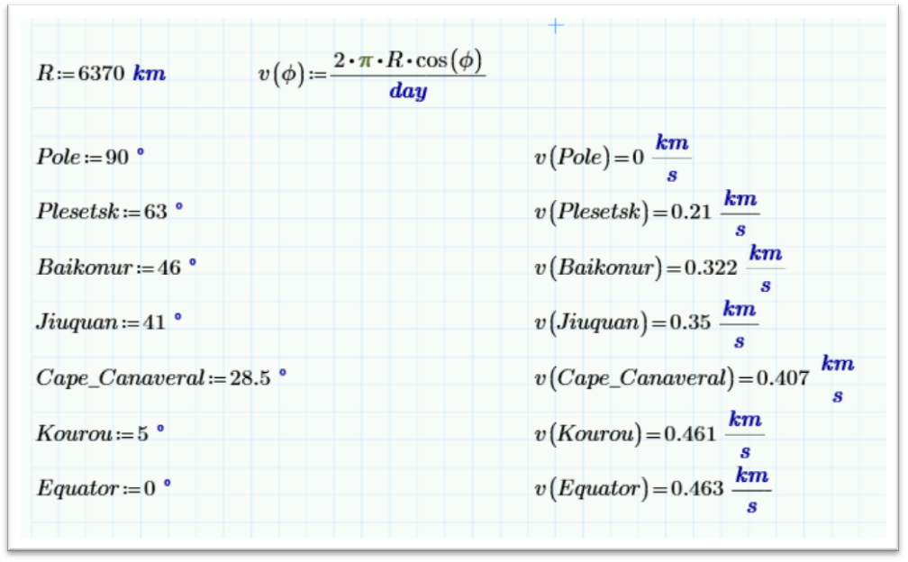
Fig. 24.7. Linear velocities on the Earth's surface
There is one more, "astronomical" factor: the orbital planes that do not coincide with the equatorial ones are unstable — the perturbing action of the Earth, the Moon and the Sun can "drop" such a satellite.
Booster rockets have several stages not only to save fuel nor to put more useful mass into orbit for a given amount of fuel, but they also ensure that the spent rocket parts do not go into orbit and fall in the given area (see above) or burn in the dense layers of the atmosphere, without clogging the near-Earth space. This aspect was not thought of at the beginning of the space age, but now it has resulted in a big problem. One often hears that the space station has changed its orbit so as not to collide with "space debris".
Discussions on the use of Mathcad for the calculation of launch vehicles can be found at the PTC Community. There are also files with the above calculations and an attempt was made to calculate the real carrier rocket "Soyuz" with three (or rather, two and a half) steps.
The same problems considered in this study were solved within the framework of the elective course on the application of modern computer mathematics systems at lyceum No. 1502 at the Moscow Power Engineering Institute.

Task for readers.
Calculate the flight parameters of a real three-stage Soyuz rocket or others, taking its starting and other data from Wikipedia, for example.

You can see it on the website: http://kino-ussr.ru/main/217-devyat-dney-odnogo-goda-1961.html. The name of this study is, by the way, a string from a famous song of those times. They sang it in the streets when they met the cosmonauts after another space expedition: "Cosmonauts and dreamers assert that ...". Listen to the song here http://pesnifilm.ru/load/mechte_navstrechu/i_na_marse_budut_jabloni_cvesti_quot_mechte_navstrechu_quot/833-1-0-1846
At the end of the dispute, the character of Kazakov (Valery Ivanovich) at the end of the dialogue throws the following phrase to his opponent (Yevgeny Evstigneev's character): " When Tsiolkovsky designed his missile, there were scientists-skeptics like you at the restaurant "Yar" and you were proving insane on napkins."
In principle, it was possible not to take into account the weight of the rocket — the product of its mass to the free fall acceleration. This assumption, as we have already noted, is embedded in Tsiolkovsky's formula.

